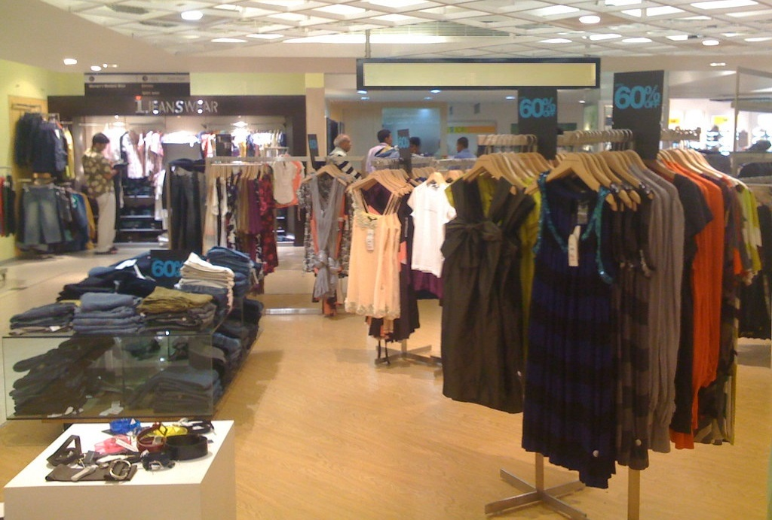

Market Analysis

Aly Hussein Ahmed Kamaledin

Data Visualizations

Abdulrahman Yaseen

Tuesday, October 17, 2023

# Project Overview

In this project, we use population statistics from the US Census Bureau to determine where the greatest income exists around the country and whether there is a correlation between sales and income. We don’t know the incomes of our customers, but we should be able to predict it by looking at their purchase history and locations and comparing that against the census data. Additionally, we want to analyze our inventory, specifically customer ratings and return rate and see if there’s a correlation between the two.

## Drawing Conclusions

* Calculating Correlation Coefficient (R2 Value) between Average Sales and Average Income for all states with the quick measure calculation on average sales. 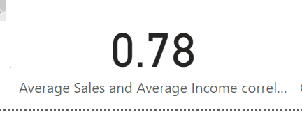
* Calculating Correlation Coefficient (R2 Value) between Customer Rating and Return Rate for all states with the quick measure calculation on customer rating. 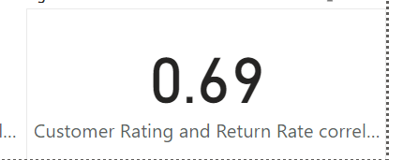
* Calculating Liner Regression Formula for predicting Sales and Income as follows:
  + m = DIVIDE([n]*[Sum_XY]-[Sum_X]*[Sum_Y],[n]*[Sum_X^2]-[Sum_X]^2) = **72.43**
  + b = DIVIDE([Sum_Y]*[Sum_X^2]-[Sum_X]*[Sum_XY],[n]*[Sum_X^2]-[Sum_X]^2) = **72638.21**
  + Final Formula: y = mX + b where X is the sales.  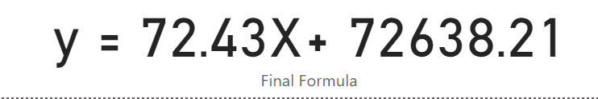
* Based on the above prediction it’s found that Jon Little has the highest income of **$452,908.85.**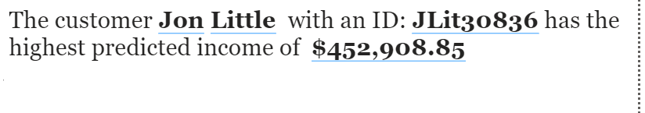 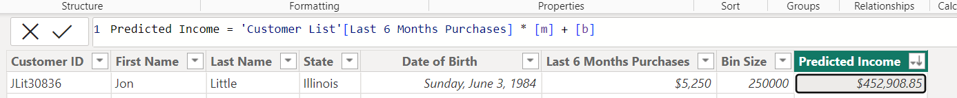
* Based on the attached histogram of categorizing the customer incomes, and the high numbers of stock for the promoted products -filtered upon- (Leather Bag, Cotton Sweater, and Spring T-Shirt), I’d recommend promoting Leather bag as it has highest price as well as the highest stock to the customers in the bin of 160000 and above, and Cotton Sweater to the customers in bin of 120000 and 140000, while the Spring T-Shirt to the customers in the bin of 100000 and below.